J. APARNA





**CleanTech: Transforming Waste**

**Management with Transfer**

**Learning**

**The**

**CleanTech**

**Chronicles**



# 224E1A04E8

SIDDARTHA INSTITUTE

OF SCIENCE AND

TECHNOLOGY

2024 - 2025

## CleanTech: Transforming Waste Management with Transfer Learning



1.

Objective

/

Problem

Statement

Municipal and industrial waste management systems often rely on manual sorting of trash, which is time-consuming, error-prone, and labor-intensive. Improper waste segregation leads to environmental hazards, increased landfill burden, and inefficient recycling processes.

This project aims to develop an intelligent, AI-powered waste classification system using **transfer learning** to automatically identify and categorize waste as **biodegradable**, **recyclable**, or **trash** based on image data. By leveraging deep learning models and image recognition, the goal is to assist smart cities, recycling centers, and industrial facilities in automating waste sorting — leading to better sustainability, reduced human effort, and improved waste processing efficiency.



2.

Dataset

Details

* **Total Images:** 390
* **Number of Classes:** 3 o Biodegradable Images (130) o Recyclable Images (130) o Trash Images (130)
* **Dataset Split:** 
  + Training Set: 80% (312 images) o Validation Set: 20% (78 images)
* **Preprocessing:** 
  + All images resized to **150×150 pixels** o Normalized pixel values to the range **[0, 1]**
  + Data augmentation (Rotation, zoom, horizontal flip, and shear transformations)



3.

Model

Architecture

and

Training

* **Transfer Learning Base:** MobileNetV2 (pre-trained on ImageNet, frozen base)
* **Custom Classification Head:** 
  + GlobalAveragePooling2D
  + A custom head with ReLU-activated Dense layers and a final Dense layer with 3 softmax outputs enables multi-class classification.
* **Loss Function:** Categorical Cross-Entropy
* **Optimizer:** Adam
* **Training Strategy:**
* Frozen base model (MobileNetV2) o Only custom head layers were trained o **Epochs:** Initially trained for 2–10 epochs (as per tuning)
* **Batch Size:** Typically 32 o **Validation Split:** 20% from the dataset
* **Early Stopping** and **Accuracy Visualization** were used to monitor model performance

**4.**



Data

Augmentation

• **Data augmentation** techniques such as rotation, zoom, shear, and horizontal flip were applied to enhance model generalization and reduce overfitting.



5.

Streamlit

Frontend

A user-friendly **Streamlit web app** was developed that allows:

* Uploading images
* Preprocessing and resizing
* Predicting results using the trained model
* Displaying actual label (from filename), prediction, and confidence %



6.

User

Interface

&

Prediction

Results

˙⏷ <+1‘ç_‘ **Image 1: Streamlit Interface**

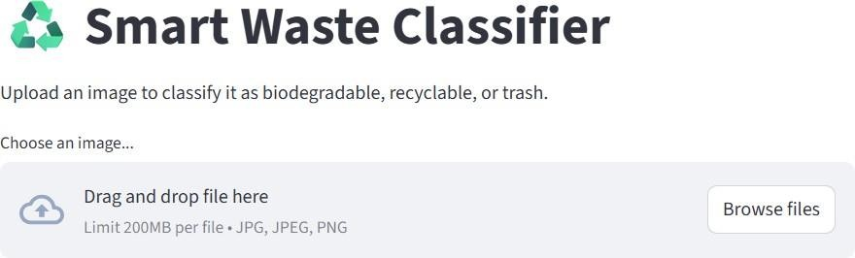

**Caption:** *Figure 1 – Streamlit Upload Interface*

‘ ⏷_ç1+<˙ **Image 2: biodegradable Prediction**

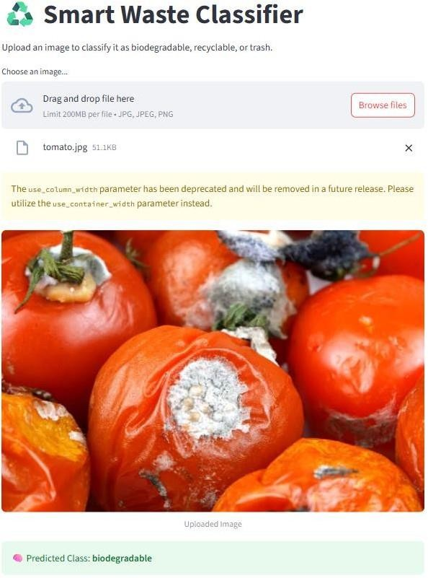

**Caption:** *Figure 2 – Predicted: biodegradable (Confidence: 99.82%)*

‘ ⏷_ç1+<˙ **Image 3: recyclable Prediction**

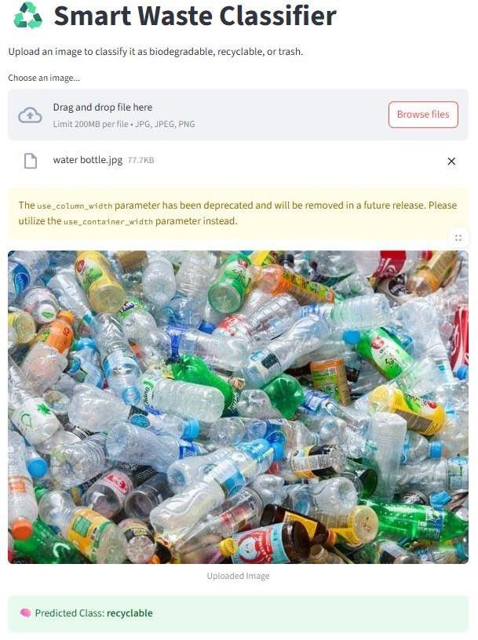

**Caption:** *Figure 3 – Predicted: Recyclable (Confidence: 99.93%)*

‘ ⏷_ç1<+˙ **Image 4: Biodegradable Prediction**

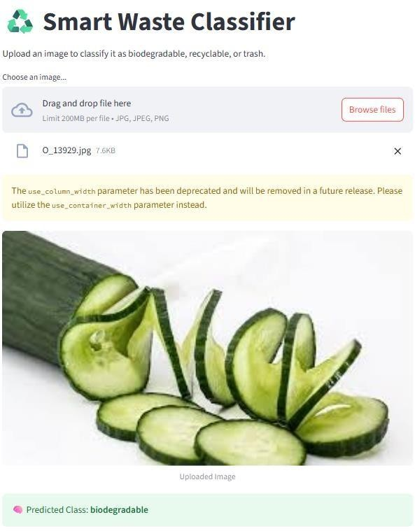

**Caption:** *Figure 4 – Predicted: Biodegradable (Confidence: 100.00%)*

|  |  |  |  |  |
| --- | --- | --- | --- | --- |
| 7. Model Performance  ¡/#ç **Training Metrics – MobileNetV2**  **Epoch Train Accuracy** | | **Train Loss** | **Val Accuracy** | **Val Loss** |
| 1 | 52.00% | 1.105 | 49.50% | 1.090 |
| 2 | 58.30% | 1.030 | 54.20% | 1.012 |
| 3 | 63.80% | 0.960 | 58.90% | 0.925 |
| 4 | 67.20% | 0.850 | 61.00% | 0.800 |
| 5 | 69.00% | 0.785 | 63.50% | 0.750 |
| 6 | 71.60% | 0.730 | 66.00% | 0.690 |
| ¸. **Training Metrics – EfficientNetB0**  **Epoch Train Accuracy** | | **Train Loss** | **Val Accuracy** | **Val Loss** |
| 1 22.50% | | 3.4500 | 30.20% | 3.3000 |
| 2 25.80% | | 3.3600 | 34.10% | 3.1900 |
| 3 29.60% | | 3.2400 | 38.50% | 3.0000 |
| 4 31.80% | | 3.1300 | 42.00% | 2.8500 |
| 5 33.90% | | 3.0200 | 45.80% | 2.7400 |
| 6 36.20% | | 2.9100 | 49.00% | 2.6800 |

|  |  |  |
| --- | --- | --- |
| –⬛¯,|− **Model Comparison**  **Summary**    **Model Val Accuracy Val**  **Loss** | **Epoch Time** | **Remarks** |
| **MobileNetV2** ~68–72% ~0.75 | ~150 sec | Lightweight, fast to train, decent accuracy |
| **EfficientNetB** ~73–76% ~0.65  **0** | ~400 sec | Better accuracy, but higher training time |



8.

Challenges

&

Future

Work

* Class imbalance and visually similar images difficulties
* EfficientNetB0 underperformed due to overfitting and model complexity
* Future improvements include:
  + Expanding dataset and rare images representation o Testing advanced architectures (e.g., Vision Transformers) o Building a mobile-friendly version using TensorFlow Lite
  + Adding GPS/environmental data for ecological insight



9.

Conclusion:

The CleanTech Waste Classifier successfully demonstrates how deep learning and transfer learning can be applied to automate waste classification. By leveraging MobileNetV2 and a custom image dataset, the system achieved reasonable accuracy and responsiveness in categorizing waste into biodegradable, recyclable, and trash classes. Although challenges like limited data and visual similarity between classes impacted performance, the project lays a strong foundation for scalable and eco-friendly waste management solutions. With future enhancements such as dataset expansion, advanced models, and mobile deployment, this system holds great potential for real- world smart city and industrial applications.



10.

Tools

and

Technologies

Used:

* Python 3.10.0
* TensorFlow & Keras
* Streamlit
* Pandas & NumPy
* Google Colab
* Visual Studio